Lab 03
Coulomb’s Law
Name: _________________________________________________________________________
Regd. No: _______________________________________________________________________
Definition

The fundamental law of electrostatics stating that the force between two charged particles is directly proportional to the product of their charges and inversely proportional to the square of the distance between them.

Description
The force exerted by one charge q on another charge Q a distance r away is given by:
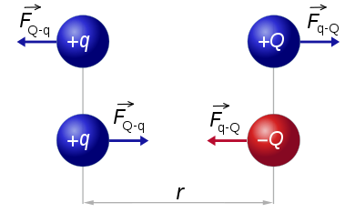
Coulomb's law: F = kqQ / r²
The constant k = 8.99 x 10⁹ N m² / C².
Remember that force is a vector. When more than one charge exerts a force on another charge, the net force on that charge is the vector sum of the individual forces.
Remember that force is a vector, so when more than one charge exerts a force on another charge, the net force on that charge is the vector sum of the individual forces. Remember, too, that charges of the same sign exert repulsive forces on one another, while charges of opposite sign attract.

The force between charges is very similar to the gravitational force between interacting masses. The equations are very similar, and in both cases the force goes as 1 / r².

An example
Four charges are arranged in a square with sides of length 2.5 cm. The two charges in the top right and bottom left corners are +3.0 x 10⁻⁶ C. The charges in the other two corners are -3.0 x 10⁻⁶ C. What is the net force exerted on the charge in the top right corner by the other three charges?
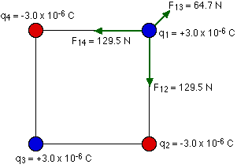
To solve any problem like this, the simplest thing to do is to draw a good diagram showing the forces acting on the charge. Force is a vector quantity, if the Force has a negative sign, its mean Force between the charges is attractive and if the Force has a positive value ,its mean that the Force between charges is repulsive.
Coulomb's law.
Multiple Charges in One Dimension (Linear)
Consider the forces exerted on the charge in the top right by the other three:
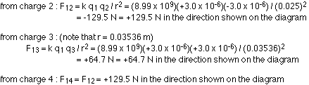
Task # 1
- Find the net Force and its Direction. Draw the direction of Force in the diagram below.
Q2=1.5*10^-7 C
Q1=-2.3*10^-7 C

- Find the net Force if Q2=-3.5*10^-4 C.

Multiple Charges in 2 Dimensions

The procedure is same, as described above .You just need to be careful about directions and use vectors to figure out the problem.
Example
Three charges are arranged in a right angle triangle as the following diagram shows.Determine the force on q2.
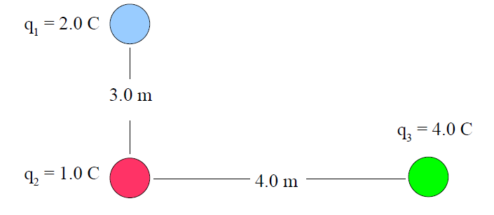
We need to start by calculating the individual forces on q2 by each of the other charges. These must be calculated individually.
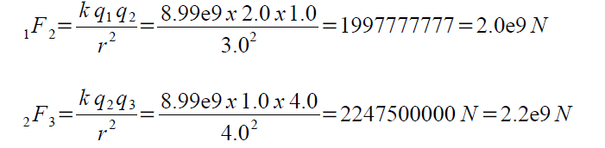
All of the charges are positive, so all of the forces are repulsive. That means that 1F2 is a force that is pushing q2 down, and 2F3 is a force pushing q2 to the left.
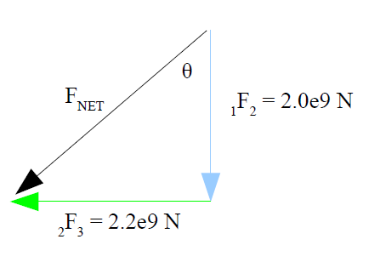
It's easy enough to calculate Fnet using Pythagoras, and figure out the angle using trigonometry
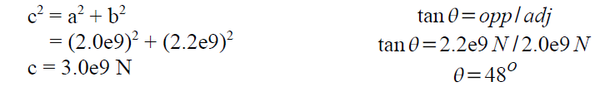
You have to be very careful to add these forces as vectors to get the net force.
Alternately,you can split the vectors up in to x and y components, add them to find the x and y components of the net force, and then calculate the magnitude and direction of the net force from the components.
Observations & Calculations
No | Q1 C | Q2 C | r m | F
1 | 3 | 7 | 0.1
2 | 3 | 7 | 0.2
3 | 3 | 7 | 0.3
4 | 3 | 7 | 0.4
5 | 3 | 7 | 0.5
6 | 3 | 7 | 0.04
7 | 3 | 7 | 0.03
8 | 3 | 7 | 0.02
9 | 3 | 7 | 0.01

Plot the graph with r along x-axis and F along y-axis.
Conclusion
Summarize what you have learned today (not what you have done).

Checked By:

----------------------------

